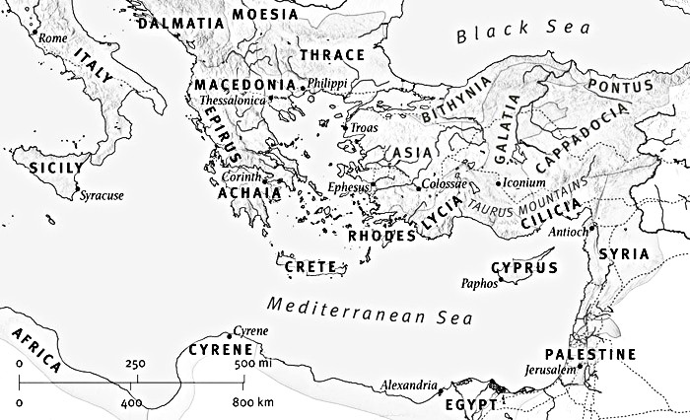

The ESV Global Study Bible Copyright © 2012 by Crossway. All rights reserved.

According To The Foreknowledge of God the Father

God’s people are where they are ____ his providential _________.

Leviticus 16:14 Leviticus 14:5-7 Hebrews 10:19-22

God’s people are where they are ____ his providential ___________.

Living in Exile – Peter’s Epistles to the Church
“Elect Exiles”
1 Peter 1:1-2
Nick Fryberger • April 19th, 2026
Big Idea: God’s people are where they are
by his providential design.

An Apostle of Jesus Christ
2 Peter 1:19-21

To Those Who Are Elect Exiles

Acts 2:39 Hebrews 11:8-10, 13-16

If we are truly in __________, this Earth is ______ our _________.

Of the Dispersion

We have more in __________ with ANY ____________ than we do
with ANY ________ person.
2 Corinthians 6:14-16a John 17:14-15

The ESV Global Study Bible Copyright © 2012 by Crossway. All rights reserved.

According To The Foreknowledge of God the Father

God’s people are where they are ____ his providential _________.

Leviticus 16:14 Leviticus 14:5-7 Hebrews 10:19-22

God’s people are where they are ____ his providential ___________.

Living in Exile – Peter’s Epistles to the Church
“Elect Exiles”
1 Peter 1:1-2
Nick Fryberger • April 19th, 2026
Big Idea: God’s people are where they are
by his providential design.

An Apostle of Jesus Christ
2 Peter 1:19-21

To Those Who Are Elect Exiles

Acts 2:39 Hebrews 11:8-10, 13-16

If we are truly in __________, this Earth is ______ our _________.

Of the Dispersion

We have more in __________ with ANY ____________ than we do
with ANY ________ person.
2 Corinthians 6:14-16a John 17:14-15

