

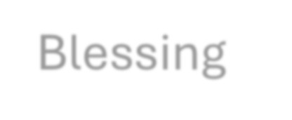
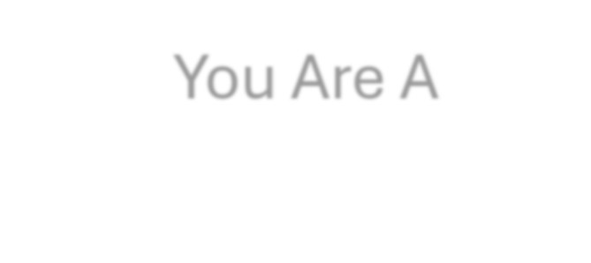
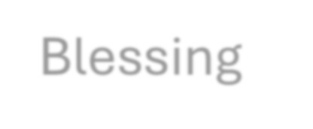
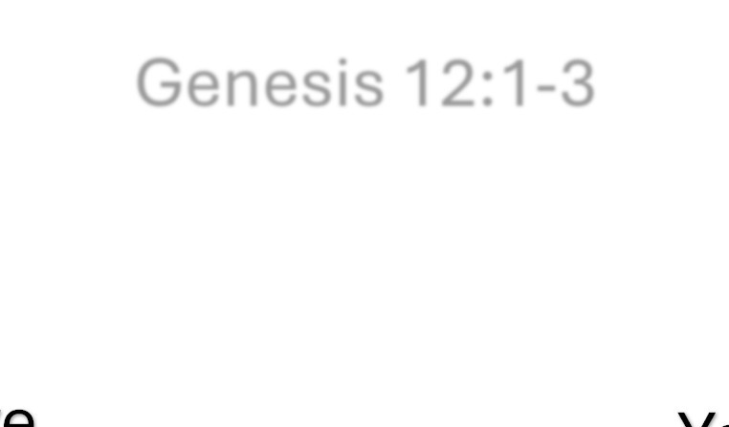

Living in – A SERIES IN FIRST PETER

e
Genesis 12:1-3
So That…
You Receiv
Blessing
You Are A
Blessing

“Blessed & Blessing”
1 Peter 3:8-12
Nick Fryberger • June 7th, 2026

Big Idea: We have been called by God to be a blessing.

- Finally… (1 Peter 3:8)
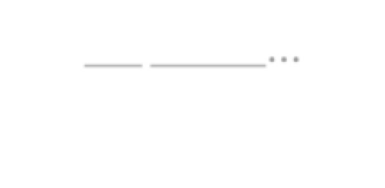

Take-aways from last two weeks (1 Peter 2.11-3:8): Our faithfully lived life is an important part of our witness.
...
1 Peter 3:9
Submission to earthly authority is an act of freedom in Christ. The Words of our mouth expose the posture of our heart.

Hebrews 10:23-25

The ( ) is supposed to be a place of

.
- For To This You Were Called (1 Peter 3:9)

1 Peter 2:21-23 1 Peter 2:24-25

We have been by God be a .
Luke 6:37-38 Matthew 25:23

- Life and Good Days…
Psalm 34:16

The is not marked by

.



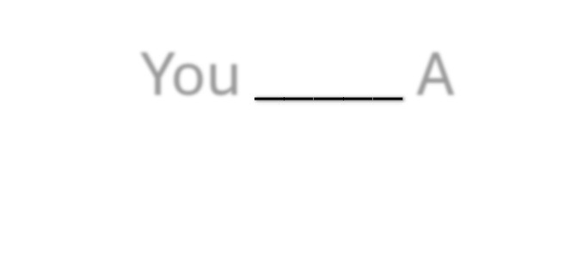

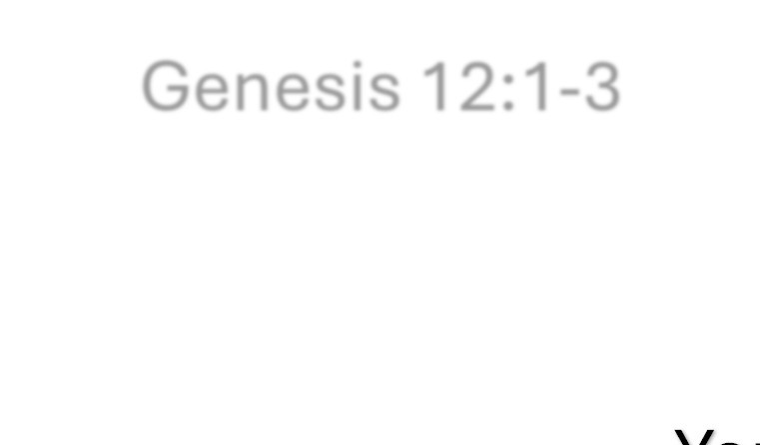

It is marked by .

___
Genesis 12:1-3
So That…
You
You A

Notes:

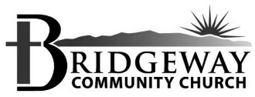
If you have questions or comments about today’s message, I would love to hear from you!

Nick Fryberger
nick@bridgewaycc.org 602.689.6665

