Prayer for Spiritual Insight
Series: Living in God’s Big Picture; Text: Ephesians 1:15-23
Pastor Gregg Cantelmo
October 8, 2017

In our text today, we see that Paul’s great concern for the Christians he was addressing was that they would know and understand God better. In this first of two prayers in the book of Ephesians, we see both praise and petition.

PRAISE (vv. 15-16)

PETITION (vv. 17-23)

- Understanding the greatness of God’s P______________.

- Understanding the greatness of God’s P______________.

- Understanding the greatness of God’s P______________.

“Ask God to open your spiritual eyes to see the greatness of His power. Jesus is alive and has conquered every enemy! You may draw on His power to meet every need in life.” Warren Wiersbe

Every real Christian is part of God’s Church, with Jesus at the head.
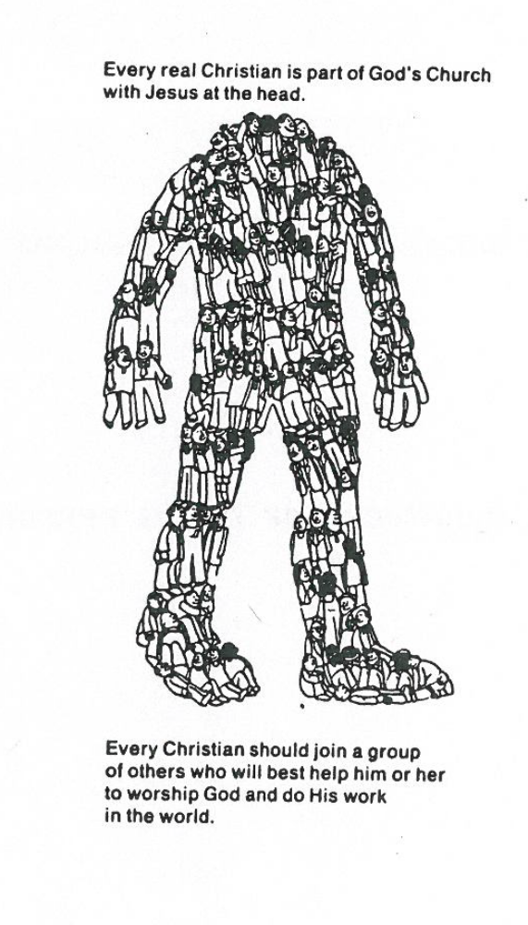

Every Christian should join a group of others who will best help him or her to worship God and do His work in the world.

